
ENGLISH HL 07 March 2026 GRADE 12 LANGUAGE NOTES: Paper 1
Summary & Advert

Notes Compiled by Ms J.Govender
GRADE 12
ENGLISH HOME LANGUAGE
MARCH 2026
TEST FRAMEWORK -PROVINCIAL TEST
DURATION: 1 HOUR TOTAL: 35
SECTION | ASPECT/SKILL
A:  COMPREHENSION  (30 minutes) | QUESTION 1  TEXT A: PROSE (24 marks)  Shortened length of text for 1 hr test: 450–550 WORDS TEXT B: VISUAL (6 marks)  Practise the comprehension/reading strategies.  Apply these strategies when answering the comprehension test.
 | - Read the title of the text and make your deduction about the content.  - Skim the first sentence of each paragraph.  - Underline the MAIN IDEA of each  paragraph. (Usually the first sentence of each paragraph).  - Underline key words/difficult words and the main ideas.  - Read the questions and identify the question words – make sure what is expected. | - Identify the core of the question.  - Make sure how many marks the question is worth and determine how many facts need to be provided.  - Study the text thoroughly.  - Level 1 and 2 questions requires simple straightforward answers.  - Rephrase/simplify sentences in the comprehension passage into your own words as far as possible.
B: SUMMARY  (15 minutes) | QUESTION 2  Shortened length of text for 1 hr test: 350 WORDS Practise the strategies for writing a summary.  Use the strategies to answer the exam question.  - Read the instructions carefully. •  - What is the question – which facts do you • have to identify? •  - Read the reading text twice.  - Underline facts related to the instruction.  - Match every underlined fact with the • instruction. |  | (90 RESPONSE)  Write in complete sentences.  Use correct punctuation.  Use the correct format – write in a paragraph.  Write down the correct number of words. Use your own words – make small changes to the sentences provided in the summary.

SECTION | ASPECT/SKILL
C: LANGUAGE  STRUCTURES  AND  CONVENTIONS  (15 minutes) | QUESTION 3: ANALYSE VISUAL TEXTS - ADVERTISEMNTS AND CARTOONS  (10 marks)  3.1 ADVERTISEMENT  Study and analyse the advertisement and pay attention to the following:
  FOCUS ON ELEMENTS STUDIED THIS TERM: media literacy, advertising, techniques and
  persuasive language
- Punctuation, capitalization, and bold • Critical language awareness. (emotive, words/letters. persuasive, manipulative language,
- Target market/audience. stereotyping, bias)
- Language usage • Is the advertisement successful?
- The function of the images/visuals – does the visual support the message of the advertisement?
FOCUS ON ELEMENTS STUDIED THIS TERM: elements of humour - caricatures, exaggeration, irony and satire)

3.2 CARTOON
Study the comic strip and pay attention to the following:
- Facial expressions: the character is frowning, eyes are wide open, mouth is wide open.
- Body language: the character's shoulders are slumped/he is pointing his finger at the character/the mother jumping in the air, his hands are balled into fists.
- Emotions conveyed by body language and facial expressions: anger/happiness/contentment/irritation/satisfaction/unhappiness/frustration.
- Focus on the caption: bold letters/capital letters/in the foreground/large letters/black letters.
- Images and other visual aspects (the stripes above the head, movement lines).
- Focus on concepts such as: manipulation/stereotyping/persuasion - Critical language awareness. • Elements of Humour

ADVERTS
 | Persuasive techniques | Aim/Intention/Purpose
1. | Visual – pictures / photos | Identify the link between the text (words) and the image (pictures).  Adds credibility, validity, authenticity.  To convince, manipulate, persuade, highlight and makes it easier to understand.  Evokes an emotive response – e.g., a little teary-eyed toddler.
2. | Use of personal pronouns  ‘We’, ‘Us’, ‘You’ or relating to a common  cause/shared view | Shows personal involvement and experience.  Adds credible, reliable, sincere and believable.  Involves us more directly.  To engage readers (participation).  Shows a shared concern – comrades/friends.
3. | Literary expressions, puns, clever sayings | To impress, astonish, imprint.  Gets the reader’s attention. Makes you remember – recall.
4. | Repetition | Has a pounding effect – hammers a point. Makes you remember - Recall. Familiar.  It emphasises.  To add credibility, validity, authenticity.  To convince, manipulate, persuade.  To emphasise, highlight.
5. | Rhetorical Questions | To provoke involvement, an emotional response, answer, reaction.  To involve reader more directly / personally.  To add credibility, validity, authenticity.
6. | Emotive Adjectives | Emotive words - e.g. A new principal. vs A new, foolish principal.  Emotive words create an expectation/bias/prejudice  … an unusual comment will now be seen as ‘foolish’. Just ONE word can swing things.  To provoke emotional responses.  To emphasise, highlight.  To engage readers - (participation).  To encourage thinking/ an OPINION.
7. | Numbers, statistics, data, research | To add credibility, validity, authenticity.  To convince, manipulate, persuade, emphasise, highlight.
8. | Arouse feelings of Guilt – manipulation/exploitation/ blackmail | Encourage a response, play on feelings.  To encourage thinking/an opinion.  To involve us more directly / personally.
9. | Font/Punctuation | Attract attention, to highlight, engage readers (participation).
11. | Celebrities/  Avarice(greed)/Lifestyle/  Attractive people | To attract attention. Celebrity endorsements build credibility-validity, authenticity.  To engage readers (participation).  To encourage thinking/an opinion.  To manipulate.
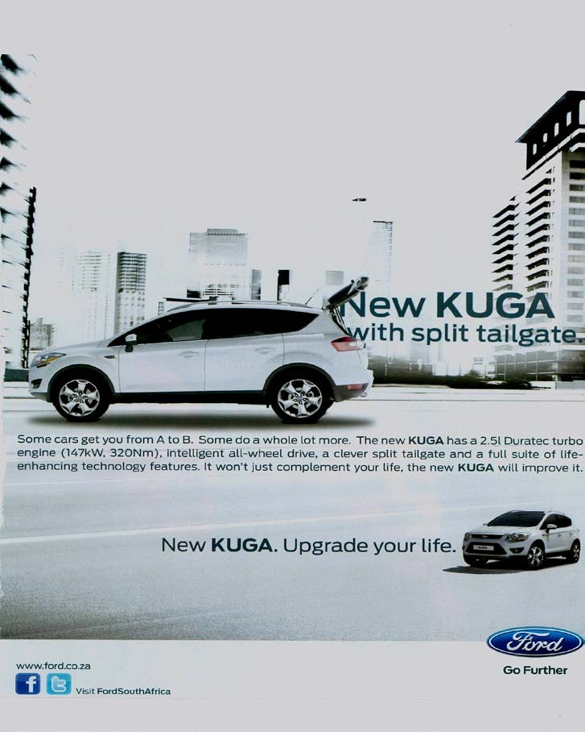
QUESTION 1 – TEXT A

[Source: Elle, August 2011]

The text in the advertisement reads:
Some cars get you from A to B. Some do a whole lot more. The new KUGA has a 2.5 ℓ Duratec turbo engine (147 kW, 320 Nm), intelligent all-wheel drive, a clever split tailgate and a full suite of life-enhancing technology features. It won't just complement your life, the new KUGA will improve it.

TEXT B

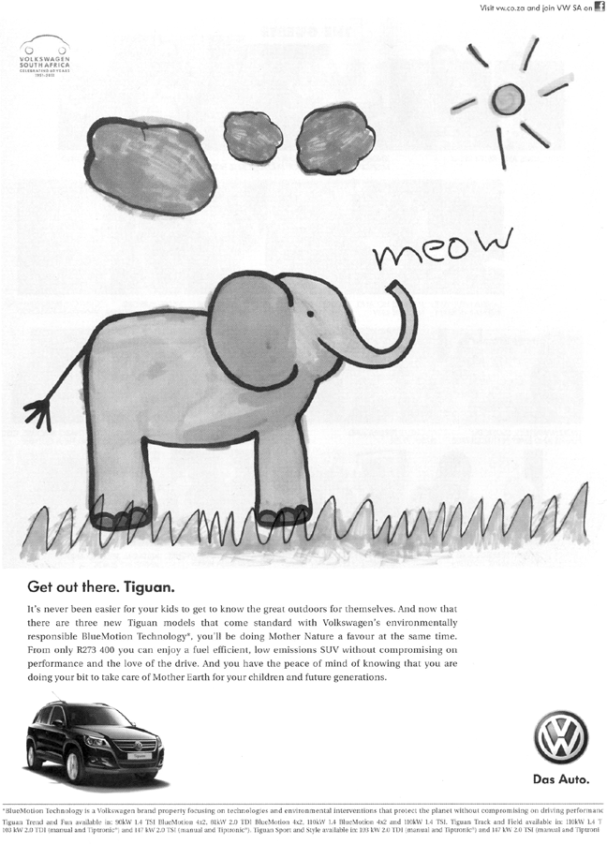

Get out there. Tiguan.
It's never been easier for your kids to get to know the great outdoors for themselves. And now that there are three new Tiguan models that come standard with Volkswagen's environmentally responsible BlueMotion Technology*, you'll be doing Mother Nature a favour at the same time. From only R273 400 you can enjoy a fuel efficient, low emissions SUV without compromising on performance and the love of the drive. And you have the peace of mind of knowing that you are doing your bit to take care of Mother Earth for your children and future generations.
*BlueMotion Technology is a Volkswagen brand property focusing on technologies and environmental interventions that protect the planet without compromising on driving performance.
 | 1.1 |  | Explain how the visual image supports the idea that the 'New KUGA' will  'Upgrade your life'. |  | (2)
 | 1.2 |  | The advertiser makes reference to 'Mother Nature' and 'Mother Earth'.  Discuss whether these phrases are appropriate in context. |  | (2)
 | 1.3 |  | In your opinion, is the illustration a suitable choice for the product being  advertised? Motivate your response. |  | (2)
1.4 |  | Carefully read the written texts of TEXT D and TEXT E.  Critically discuss the effectiveness of the style and language in conveying the intention of each of the advertisers. |  | (4)  [10]

MARKING GUIDELINES
1.1 | The car is positioned amid modern city business blocks, suggesting that the  owner is highly successful. | (2)

1.2 | Yes.  Personifying nature shows that the company values the environment/gives the impression that the company prioritises environmental issues. 'Mother' has positive connotations such as nurturing. | (2)

1.3 | Yes.  The advertisement targets parents who would like to expose their children to the outdoors and/or are concerned about environmental issues. It captures attention since it is an unusual illustration for a vehicle. The fact that it is so much larger than the visual of the car conveys the advertisers concern for environmental issues in their technologies. The clouds, grass and sun are also relevant ideas. 'Meow' is 'cute'/ childlike and has pleasant connotations/links to a child's innocent consciousness.  No.  The childlike drawing detracts from the technological features of the product. It is unrealistic to believe that the public would accept the claim that families and the environment are the company's major concern. (2)
1.4 TEXT A:
The intention is to attract a yuppie market/those who are image-conscious and ambitious with the short, snappy style and pseudo-scientific jargon. This is clearly captured in 'intelligent' and 'clever', suggesting that those who are bright and young will be attracted to the advanced technology offered. The term 'upgrade' links the car to the digital revolution which is important in the lives of such people.

TEXT B:
The whole advertisement is emotive, longer and colloquial. It plays on the currently fashionable interest in environmentalism. The emphasis on 'Mother', 'children' and 'future generations' is meant to appeal to young families. (4)

SUMMARY

Summarising Skills
To perfect the summary, it takes PRACTISE! PRACTISE! PRACTISE!!!
Take note:
- A summary is a BRIEF statement or account of something.
- You are instructed to summarise in PARAGRAPH form only so you must be able to construct a coherent, FLUENT SINGLE PARAGRAPH.
- Understand that summaries should be written in YOUR own words.
- Write in full sentences and try NOT to exceed 12 words per sentence.
- If you learn how to answer the summary correctly, you CAN score full marks.
- Avoid using quotations (as it appears in the original text).
- Use words like synonyms, pronoun replacements and try to write in simple sentences. It works really well.
- Where possible, try to rewrite a sentence from the active voice into the passive voice.
- Use your own words does NOT mean give your OPINION.
- Make sure to have a copy of the rubric when you are practising the summary and become familiar with it.
- Label ‘Rough Work’.
- Label ‘Final Copy’.

2.2 HOW TO ANSWER THE SUMMARY QUESTION
RESOURCE: SCE/NSC EXAMINATIONS PAPER 1: 2021
CHECKLIST
NOTE:
- Your summary should include SEVEN points and NOT exceed 90 words
- You must write a fluent paragraph
- You are NOT required to include a title for the summary.
- Indicate your word count at the end of the summary.
FOR GRIPS TECHNIQUE
F - Figurative Language x G - Generalizing
O – Own Words R- Repetition x
R - Reported Speech I- Illustrations /examples/statistics x
P- Plan
S – State no. of words

The following TEXT discusses research done on the spread of fake news. Summarise, in your own words, the research undertaken on fake news.

WHY FAKE NEWS ON SOCIAL MEDIA TRAVELS FASTER THAN THE TRUTH
False news is more novel than true news, and that may be why we share the false much faster and more widely. Prominent responses to false news include surprise, fear and disgust. True news tends to be met with sadness, joy, anticipation and trust. Humans are more likely than automated processes to be responsible for the spread of fake news.

Researchers have studied what they term 'rumour cascades'. A cascade starts with a Twitter user making an assertion about a topic – with words, images or links – and continues in an unbroken chain of retweets. The researchers analysed cascades about news stories that six fact-checking organisations agreed were true or agreed were false. The study found that 'falsehood diffused significantly farther, faster, deeper and more broadly than truth in all categories of information'. Of all categories of fake news, false political news reached more people faster and went deeper into the networks than any other category of false information.

The study compared the emotional content of replies to true and false rumours by using about 32 000 Twitter hashtags and a lexicon of about 140 000 English words that are associated with eight basic emotions: anger, fear, anticipation, trust, surprise, sadness, joy and disgust. Were automated processes, or 'bots', the main culprits in spreading falsity? No – the researchers found that humans were responsible for spreading false news.

The researchers were more interested in identifying the factors that spread true and false news; they included interviews with users, surveys, lab experiments and neuro-imaging. The researchers' paper points to some obvious reasons to look deeper. False news can drive misallocation of resources during terror attacks and natural disasters, the misalignment of business investments, and misinformed elections.

More openness by the social media giants and greater collaboration by them with suitably qualified partners in tackling the problem of fake news is essential. Traditional journalists are potential partners too. Since they find, check and disseminate news, they are well placed to assess the reliability of the reports that they receive. They also attract masses of comments online and generate discussions on social media platforms – they have a clear incentive to maintain trust in their own contributions to democratic life.
Marking Guidelines – 2021 -Summary
Researchers focused on the chain reaction caused by Twitter users. Subsequently, organisations were appointed by the researchers to verify the stories' authenticity. Research revealed that false news, particularly fabricated political news, spreads more rapidly and pervasively than authentic news. Researchers analysed replies to rumours by studying hashtags and emotionally-charged words. Various methodologies were used to isolate the factors causing the spread of fake news: people, not robots, are responsible for spreading fake news, which can lead to devastating financial and political consequences for society./It is essential for social media giants to work together with all concerned to deal with fake news. Journalists, too, have to ensure the authenticity of the news that they receive and share.

